Week 3 Assignment
Part 1
Given the scenario of having test cases to be implemented for a program that purportedly manages a list of items through hash coding, we first need to very briefly know what it exactly is and does.
Hash tables are a fundamental yet very important and efficient data structure that provides a way of associating pairs of data (a key and its corresponding value), or to keep track of unique items. This allows writing and reading of items almost instantly. Hash tables are widely used but not limited to index database, caching, creating new data structures (like dictionaries in python), verifying data integrity and much more.
For a program utilizing such techniques and approaches, I would apply following test cases to test the correctness of the program’s function while covering the very characteristics of a hash table and the way it functions.
- Lookup in an empty hash table
As expected, the program should return a correct insertion location instead of falsely indicating the item’s presence. Also, I expect the program to return a flag indicating the presence of the item. Else, I would never know whether the returned location is an existing one, or a new available slot.
- Insertion and lookup
After above case is tested, I would then insert a new item (e.g. item1) and lookup its location. By this point, I expect the program to insert and return me the inserted/hashed location to ensure that the table actually do store and return an item’s correct location.
- Collision testing
At this point, I like to perform a collision test to ensure multiple items with keys resulting in similar index/space/slot are handled smoothly.
Suppose there are two items with keys “stop” and “pots”. Now let us assume that the program’s hash function’s hashing/indexing logic is such that both the keys results to the same index/slot in the table, there would be two sub-cases that I would want to try.
- Missing collision
I insert an item with the key “stop”, know its inserted location, and check if an item with the key “pots” exists. The function/program should provide me proper indication of the item’s absence regardless of both the item indicating to the same location in the table.
- Found collision
Similarly, I insert both the item respectively and search for the later item (i.e. pots). This should without a doubt return me the correct location of the item itself even though the function’s algorithm may encounter the location of ”stop” prior.
This case ensures that collision handling is well implemented by the function that not only generates hash/index of an item, but also compare keys to actually distinguish between the items even if the both point to the same location. A proper hashing function should always allocate conflicting item’s location using different techniques such as Separate Chaining and Open addressing.
- Test table edges
Testing table boundaries is also one of the most important cases that needs to be tested to ensure all the allocated spaces can be used given the table size.
I would write and read item to and from the very first and the last index/space in the table to ensure off-by-one error is handled properly. Reading/writing from/to illegal indexes is expected to be prevented by the program.
- Duplication handling
A hash table should prevent data duplication at its best. If duplicate item is encountered, the program is expected to either halt the operation by informing the user/operator, or override to the current value.
For this, I would insert an item (say with the key “item1”) and try inserting another item with different value but with the same key. I would then read the item at last to figure out what approach the hash function uses amongst halting, or overriding.
- Capacity test
Reading and writing data from/to the table if fine until this point, would lead me to test how the function handles overflow. For this, I would fill items to every slot possible in the table, and try inserting a new item to check the behavior of the function and/or program itself.
By default, I expect the program to display some graceful warning, an error, or a message indicating the nature of the operation. No other operation such as overriding to other occupied location should be allowed.
- Input sanitization
Whether it is a form data or URI parameters, sanitizing inputs are one of the preliminary steps done to avoid data issues and unexpected errors. As of this point, I would try inserting an item with slight changes in its key. E.g. I would trying using different techniques to use the item’s key such as an empty string (“”), white spaces (“ “), numbers only (“1234”), special characters only (“|%}”), their combinations (“ %123%”), and so on.
This is to test whether or not the function/program rejects the invalid key’ed data, auto sanitizes them, or is stored directly – which in turn provides us insight on the program’s behavior on potential malformed input.
References
- Hash table - Wikipedia
- Collision Resolution Techniques - GeeksforGeeks
Part 2
Hashing algorithm is one of the greatest feat in computer and its security. It is a way of masking data/input to a fixed length gibberish which is completely irreversible. It is used from tiny everyday operations to massive-scale systems such as hash tables in programming languages, checksums for file integrity, password storage, digital signatures, blockchains and much more.
As mentioned in the scenario presented in this part, use of hash coding to confirm what I received from repository is what it actually contains, can be done within several yet simple steps provided below. It is to note that throughout the steps below and wherever applicable, I will be using an example of the repository being Download Ubuntu Desktop | Ubuntu to download and install Ubuntu OS. But it doesn’t mean that the below steps apply only for this particular example.
- Download the program/file from a repo.
- Check if the repo provides md5 or similar hash digest/checksum and/or signature file along with the file.
  - If provided:
    - Download the program, the hash, and/or the signature file.
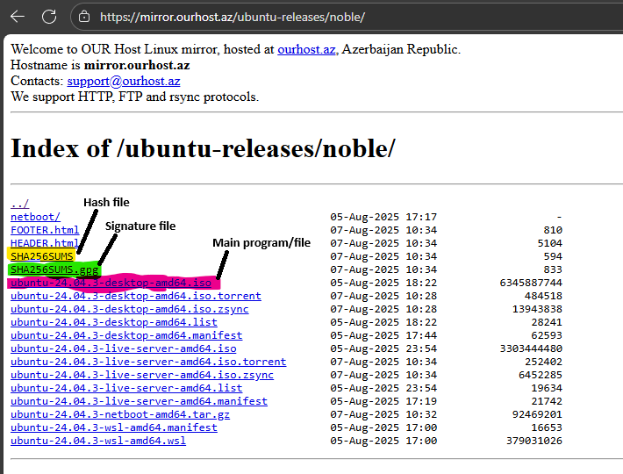
    - Generate and compare the hashes (Using Windows 11 with CertUtil)
Run the command as demonstrated in the attached image below.
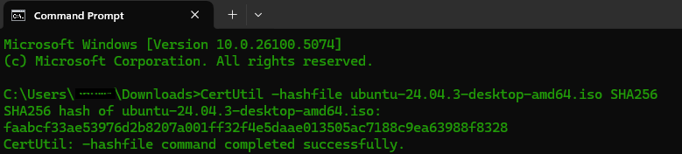
As we can see, SHA256 hash has been generated for the .iso file we wanted to test the integrity of. Now if we compare the hash string from downloaded SHA256SUMS and the output above, we will find it equal as no tampering was done with the .iso file.
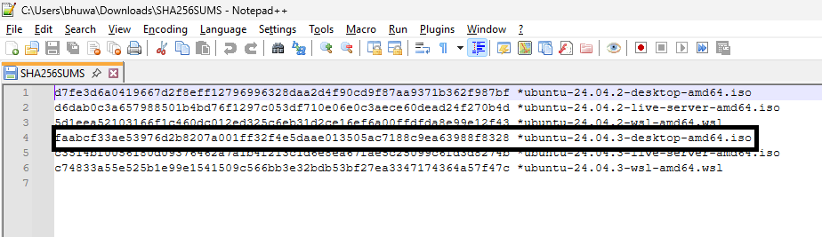
    - Verify the authenticity of hash itself
Even though the file’s integrity is solid, we can’t trust the file and the hash itself because if a file is compromised, then it’s more likely that the hash file is also compromised. Thus, to check the authenticity of the hash that guarantees the hash itself is valid and is signed by the owner (Ubuntu in this case), we verify the .gpg signature file with the owner provided public key as follows.
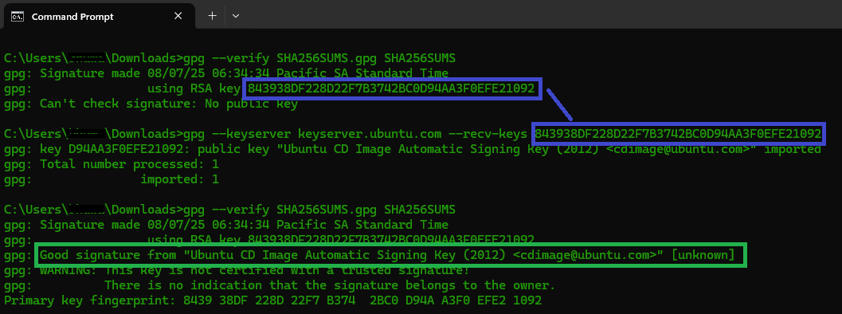
If the file hash integrity and authenticity passes, we can safely conclude that the file and its provided hash is indeed legit.
  - If not provided, then we can query if developers have posted hash values on some separate channels and/or media like signed email, official blog or on something similar, and then continue above steps sequentially.
References
- Download Ubuntu Desktop | Ubuntu
- Index of /ubuntu-releases/noble/
- Gpg4win - Get Gpg4win

